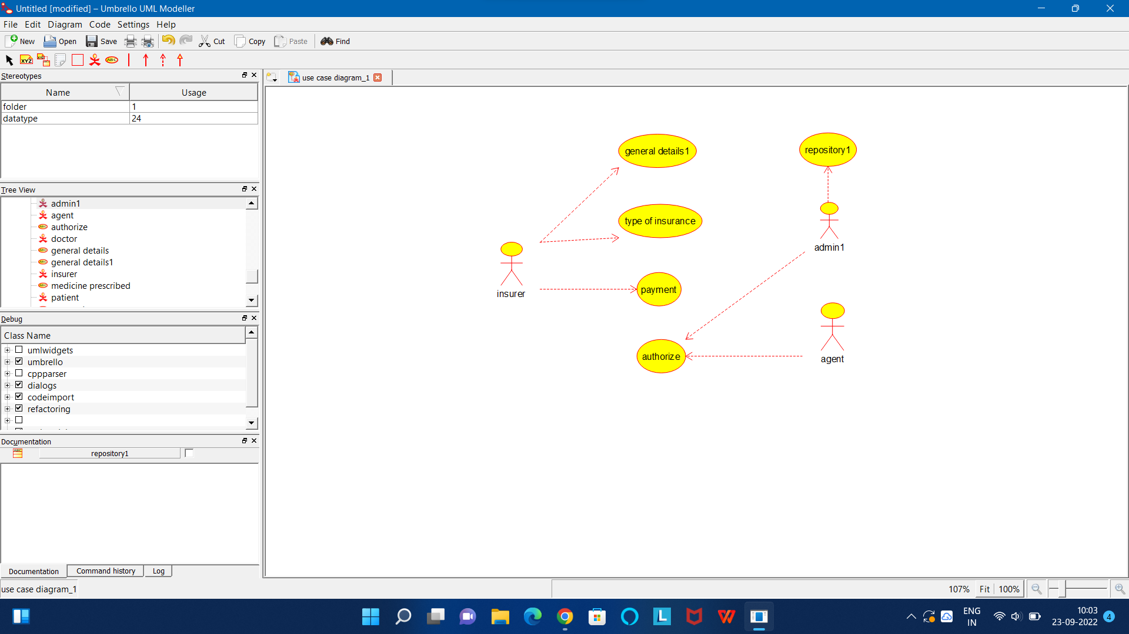

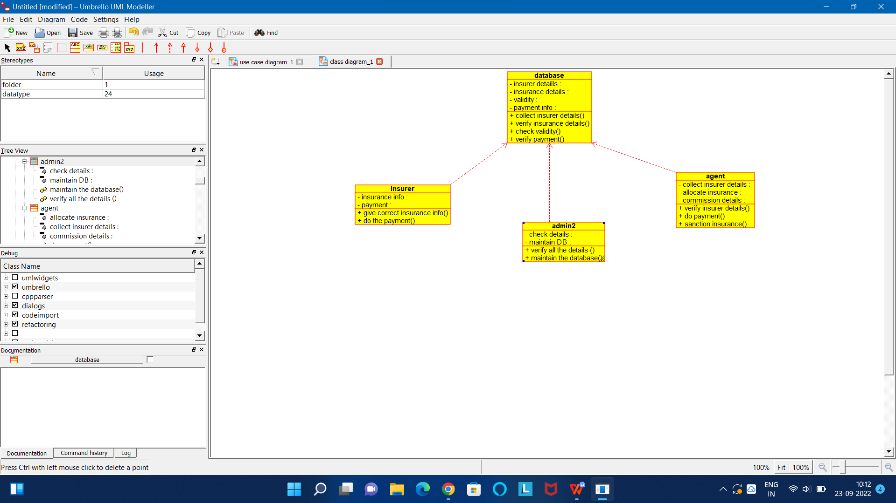

CODE FOR ADMIN2:

/**

* Class admin2

*/

public class admin2 {

//

// Fields

//

private void check_details;

private void maintain_DB;

//

// Constructors

//

public admin2 () { };

//

// Methods

//

//

// Accessor methods

//

/**

* Set the value of check_details

* @param newVar the new value of check_details

*/

private void setCheck_details (void newVar) {

check_details = newVar;

}

/**

* Get the value of check_details

* @return the value of check_details

*/

private void getCheck_details () {

return check_details;

}

/**

* Set the value of maintain_DB

* @param newVar the new value of maintain_DB

*/

private void setMaintain_DB (void newVar) {

maintain_DB = newVar;

}

/**

* Get the value of maintain_DB

* @return the value of maintain_DB

*/

private void getMaintain_DB () {

return maintain_DB;

}

//

// Other methods

//

/**

*/

public void verify_all_the_details_()

{

}

/**

*/

public void maintain_the_database()

{

}

}

CODE FORCODE FOR DATABASE:

/**

* Class database

*/

public class database {

//

// Fields

//

private void insurer_detaills;

private void insurance_details;

private void validity;

private void payment_info;

//

// Constructors

//

public database () { };

//

// Methods

//

//

// Accessor methods

//

/**

* Set the value of insurer_detaills

* @param newVar the new value of insurer_detaills

*/

private void setInsurer_detaills (void newVar) {

insurer_detaills = newVar;

}

/**

* Get the value of insurer_detaills

* @return the value of insurer_detaills

*/

private void getInsurer_detaills () {

return insurer_detaills;

}

/**

* Set the value of insurance_details

* @param newVar the new value of insurance_details

*/

private void setInsurance_details (void newVar) {

insurance_details = newVar;

}

/**

* Get the value of insurance_details

* @return the value of insurance_details

*/

private void getInsurance_details () {

return insurance_details;

}

/**

* Set the value of validity

* @param newVar the new value of validity

*/

private void setValidity (void newVar) {

validity = newVar;

}

/**

* Get the value of validity

* @return the value of validity

*/

private void getValidity () {

return validity;

}

/**

* Set the value of payment_info

* @param newVar the new value of payment_info

*/

private void setPayment_info (void newVar) {

payment_info = newVar;

}

/**

* Get the value of payment_info

* @return the value of payment_info

*/

private void getPayment_info () {

return payment_info;

}

//

// Other methods

//

/**

*/

public void collect_insurer_details()

{

}

/**

*/

public void verify_insurance_details()

{

}

/**

*/

public void check_validity()

{

}

/**

*/

public void verify_payment()

{

}

}

CODE FORCODE FOR INSURER:

/**

* Class insurer

*/

public class insurer {

//

// Fields

//

private void insurance_info;

private void payment;

//

// Constructors

//

public insurer () { };

//

// Methods

//

//

// Accessor methods

//

/**

* Set the value of insurance_info

* @param newVar the new value of insurance_info

*/

private void setInsurance_info (void newVar) {

insurance_info = newVar;

}

/**

* Get the value of insurance_info

* @return the value of insurance_info

*/

private void getInsurance_info () {

return insurance_info;

}

/**

* Set the value of payment

* @param newVar the new value of payment

*/

private void setPayment (void newVar) {

payment = newVar;

}

/**

* Get the value of payment

* @return the value of payment

*/

private void getPayment () {

return payment;

}

//

// Other methods

//

/**

*/

public void give_correct_insurance_info()

{

}

/**

*/

public void do_the_payment()

{

}

}